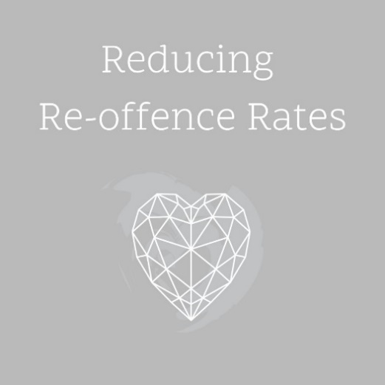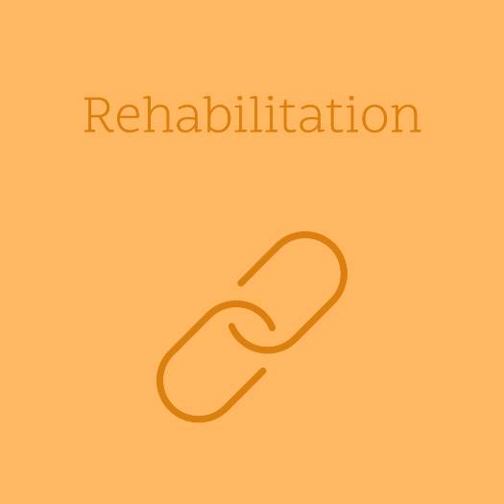



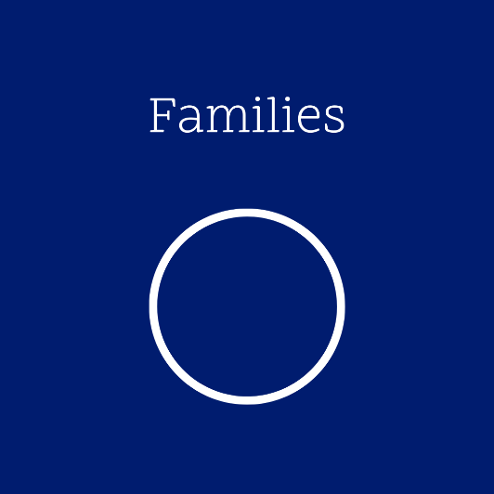

**GRACE HOUSE IS ALL ABOUT**

* Reducing re-offence rates from the current average of 60%.
* Rehabilitation that supports women to lead happier, crime free lives.
* Training & Education that gives the tools they need to prevent re-offending, and for a better future upon release.
* Housing to provide a safe place of support as the women integrate back into society.
* Families - to see separated families made whole and generational crime reduced.

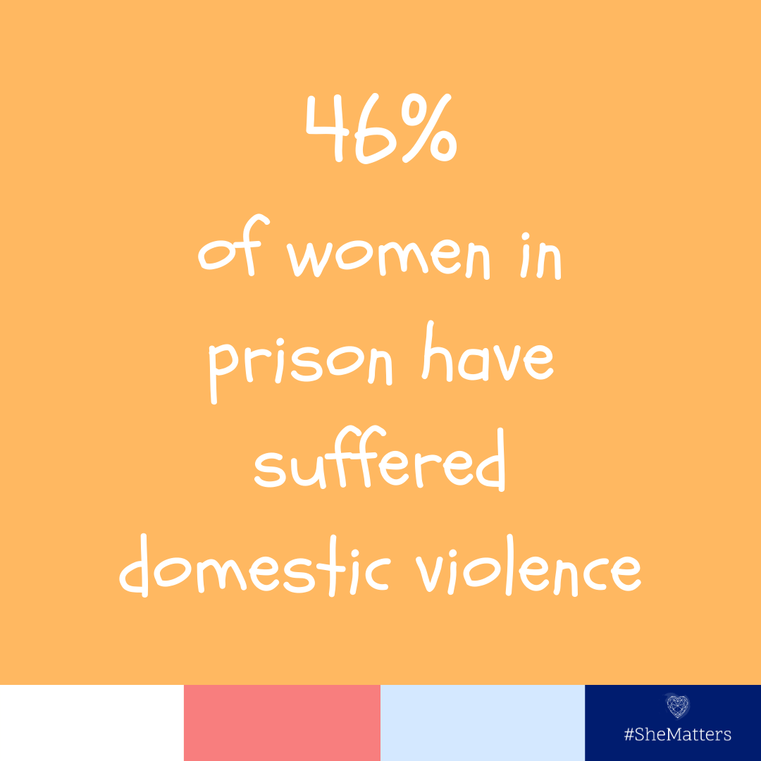 

**A shocking statistic but – 53% of women in prison have suffered emotional or sexual abuse as a child, 24% have been in the care system and 46% have attempted suicide at some point in their lives.**

**Grace House will provide counselling to help women who have faced trauma find healing.**

Many women in prison are mothers. The women’s histories of abuse and trauma, mental illness and mothers’ guilt, grief and distress at separation from their children all increase their suffering.

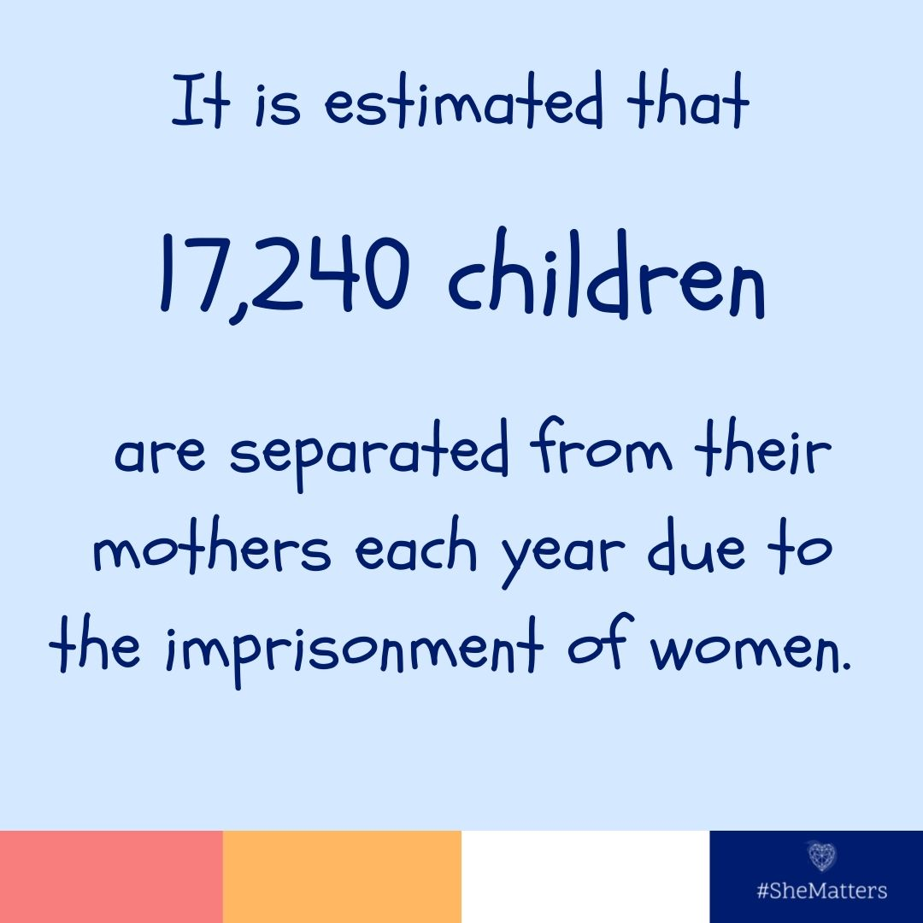 

“About 13,000 women are sent to prison in the UK every year, twice as many as 20 years ago, many on remand or to serve short sentences for non-violent offences, often for a first offence. Thousands of children are separated from their mothers by imprisonment every year. Yet most of the solutions to women’s offending lie in the community." - Prison Reform Trust report, 'We're in trouble.'

Fewer than one in ten children are cared for by their father when a mother goes to prison and only 5% remain in their own home.  
  
Supporting women in their journey to become better role models and parents to their children is a huge part of the work of Grace House.

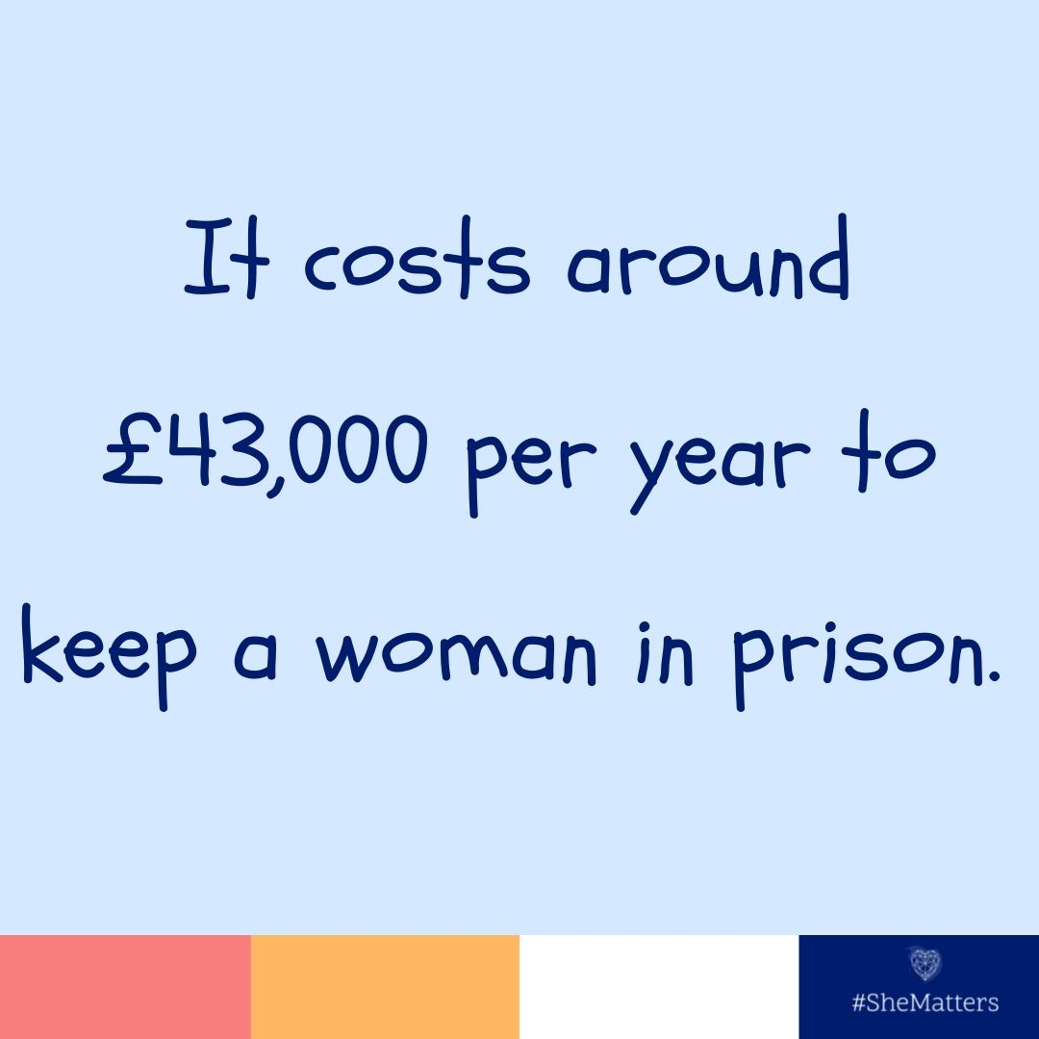 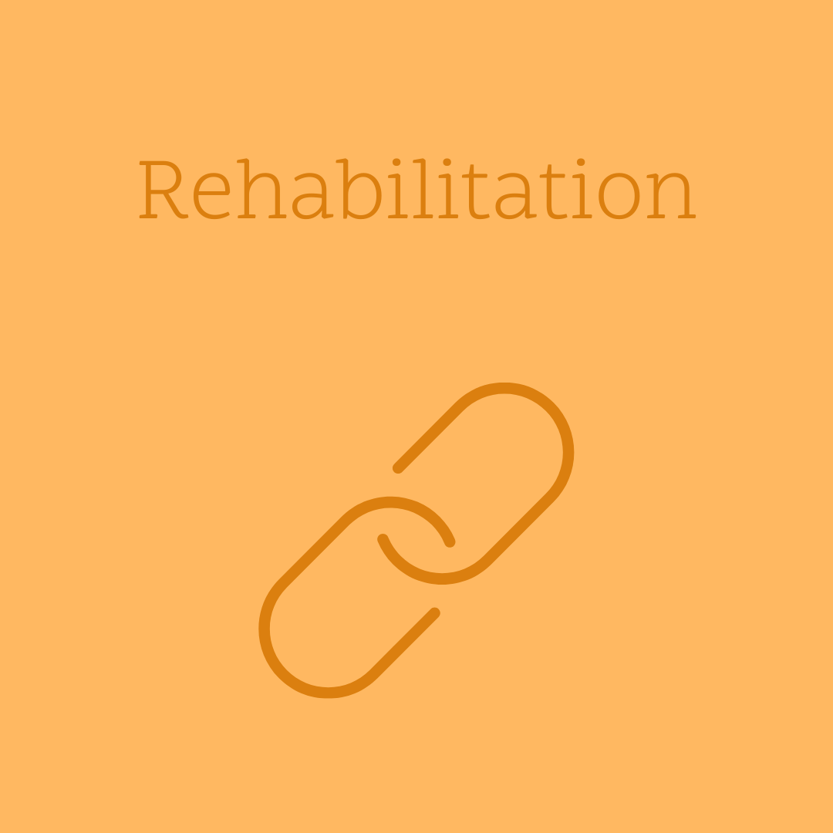

Rehabilitation is about giving women the tools needed to change the direction that their lives have taken to date.

Grace House will offer life skills training to all our residents – finding work, finding decent safe housing, budgeting, healthy lifestyles and healthy relationships.

It costs around £43,000 per year to keep a woman in prison. Providing women at Grace House UK with the tools to choose a different path away from crime will not only improve the lives of both the individual and their families but that of society as a whole.



### **REGULAR GIVING & GIFT AID**

Our **Grace House Giving** campaign is an excellent opportunity for you to partner with us in our work.

### **ONE OFF DONATION**

One off donations can be made **ONLINE** at **www.gracehouseuk.org**

Alternatively, a **CHEQUE** payable to **Imago Dei Prison Ministry**, **Reference -** **Grace House** can be sent to:

**Imago Dei Prison Ministry  
PO Box 830   
East Grinstead  
RH19 9GU**

### **OUR BANK DETAILS ARE:**

## ****CAF BANK****

Account Name: ID Grace House  
Account No: 00034165  
Sort Code: 40-52-40



**HOW CAN YOU SUPPORT US?**

Below are a few ways in which you can partner with us and support Grace House.

**PRAYER**

We believe in the power of prayer. Prayer is pivotal to all that we do and the backbone to our ministry. It is vital that those of us who work in Grace House know that we are covered in prayer and supported in this way each and every day. It makes a huge difference.

Go to our website to sign-up to receive regular email prayer requests 3 times a week and join in praying for this ministry.

**SHOPPING**

You can be supporting ID Prison Ministry even as you shop online! *Go Raise* partners with a wide range of shops and restaurants and donates to ID Prison Ministry when you shop via the *Go Raise* website. Also, if you shop via *Amazon Smile* instead of Amazon, they will donate 0.5% of your purchase to us.

It only take 5 minutes to set up, and can make a big difference to us without you having to do anything further!

**FUNDRAISING**

Visit our websitefor more information on upcoming Events you might like to take part in. We also have some great ideas and ways that you can fundraise for us.

**www.gracehouseuk.org**

**GRACE HOUSE**

**Grace House** is a project of ID Prison Ministry, set up specifically to offer housing with life skills training and support for women leaving prison that may otherwise be homeless and need further resettlement provision.  Our aim is to help our residents integrate back into the community well.  But more than that, we want to give them hope for a better future.

**GRACE HOUSE - HOPE FOR A BETTER FUTURE**

**A Better Future – for women at Grace House.**  In our referral prisons, an average of 300women each year come out of prison homeless.  We want to give some of them a safe, comfortable house to stay in and to invest in them through our Preparation Training and support.  Our residents will be able to work towards a better future.

**A Better Future – for our communities.**  The re-offending rate for women is on average 54.5%. By reducing that figure for our residents we get fewer crimes on our streets.  It costs around £35,000 per year to keep one woman in prison which puts the re-offending cost to society at almost £72m per year.

**PREPARATION TRAINING- 5 THEMES**

**WORK | RUNNING A HOME | EMOTIONAL HEALTH RELATIONSHIPS | PHYSICAL HEALTH**

We will also offer support in the form of counselling and life coaching.  Our trained Resident Mentors will work closely with each woman to help them set and achieve goals towards independent living.

Grace House is a Christian charity and our primary goal is to ensure all residents are able to find a place in society where they can thrive.  Grace House will be open to women of all faiths and none. Their views and beliefs will always be respected and honoured.

**GROWTH | RESETTLEMENT | ACCEPTANCE | COMFORT | ENCOUNTER**

Because we are a Christian project, prayer will be central to all we do as a staff team. Our hope is that every woman will encounter the love of God throughout their stay with us.

We believe that each woman is unique and has within them gifts and talents that will help them to live a full and crime free life.

**www.gracehouseuk.org**